**Practice 5**

1. Execute the command in the lab_05_01.sql file to create the messages table. Write a PL/SQL block to insert numbers into the messages table.

a. Insert the numbers 1 to 10, excluding 6 and 8.

b. Commit before the end of the block.

c. Execute a SELECT statement to verify that your PL/SQL block worked.  
You should see the following output:

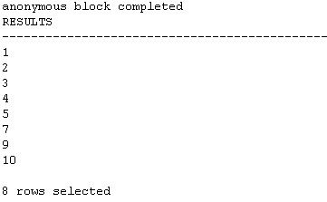

1.Execute the lab_05_02.sql script. This script creates an emp table that is a replica of the employees table. It alters the emp table to add a new column, stars, of VARCHAR2 data type and size 50. Create a PL/SQL block that inserts an asterisk in the stars column for every $1,000 of the employee’s salary. Save your script as lab_05_02_soln.sql.

a. In the declarative section of the block, declare a variable v_empno of type emp.employee_id and initialize it to 176. Declare a variable v_asterisk of type emp.stars and initialize it to NULL. Create a variable sal of type emp.salary.

b. In the executable section, write logic to append an asterisk (*) to the string for every $1,000 of the salary amount. For example, if the employee earns $8,000, the string of asterisks should contain eight asterisks. If the employee earns $12,500, the string of asterisks should contain 13 asterisks.

c. Update the stars column for the employee with the string of asterisks. Commit before the end of the block.

d. Display the row from the emp table to verify that your PL/SQL block executed successfully.

e. Execute and save your script as lab_05_02_soln.sql. The following should be the output:

